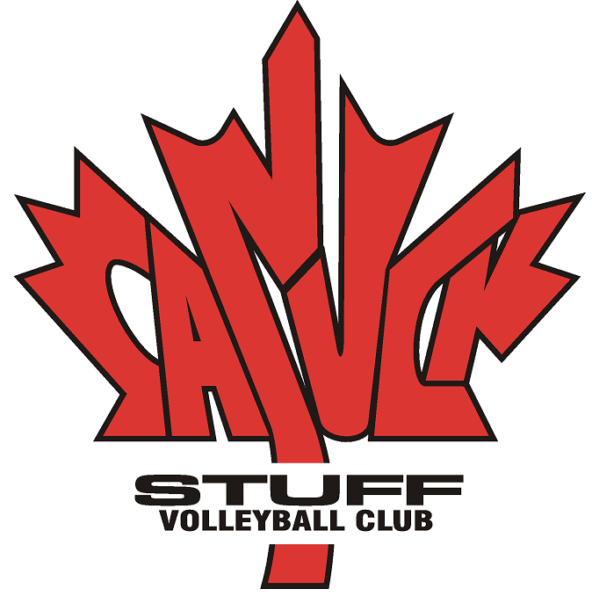

Participating Athlete Behavior Agreement

Operating a since 1988, the Canuck Stuff Volleyball Club, (CSVC), emphasizes the ideals of good sportsmanship and physical fitness.

To clearly communicate our values it is in the best interests of all participants in the sport of volleyball at CSVC to understand that our Club athletes are expected to fulfill certain responsibilities and obligations. These include, but are not limited to, complying with the policies, rules and regulations of the CSVC.

The following Code of Conduct identifies the standard of behavior which is expected of all CSVC athletes. Club athletes who fail to meet this standard of behavior will be subject to disciplinary actions.

Code of Conduct
CSVC athletes shall conduct themselves so as to reasonably comply with the following:

- Attend all practices and sessions regularly and punctually and notify coaches of late or absenteeism.
- Cooperate fully with all reasonable requests of club directors, coaches, officials and, or, everyone authorized by CSVC to provide volleyball activities and other services.
- Refrain from the consumption or possession of any alcoholic beverages, illegal drugs or tobacco products (no smoking).
- Opposite sex athletes are not permitted in each other’s hotel rooms at any time unless accompanied by a chaperone or coach and doors must remain open.
- Respect all property associated with CSVC including facilities, equipment and personal properties. No vandalism. No theft.
- Avoid acts of rude or abusive conduct, including language considered racist or sexist, directed at opponents, teammates, coaches, officials or spectators.
- Avoid any action or conduct that would disrupt or interfere with the operations of the CSVC.
- Behave in an exemplary manner. Practice good sportsmanship and be a positive example on and off the playing court. Whether you win or lose, show respect to opponents, coaches, officials and spectators. Play hard. Play fair.
- Adhere to the regulations and curfews established by the CSVC for athletes participating in out of town tournaments.
- Do not leave designated areas during tournaments or practices unless previous arrangements are made and the coaches/chaperones have been notified.
- Athletes must travel to and from out of town tournaments with an adult/guardian, not in a vehicle driven by another athlete, unless written authorization is provided by the parent or guardian.
- Avoid pranks, jokes, fighting or other activities which may endanger the safety of others.

Over…

Disciplinary Actions (Procedures)
Most first time infractions as listed below as examples of minor infractions will be dealt with by the coaches and/or the club administrator.

Examples of minor infractions
- A single incident of disrespectful, offensive, abusive, racial, or sexist comments or behavior towards others, including but not limited to peers, opponents, athletes, coaches, officials, administrators, and spectators.
- Unsportsmanlike conduct such as angry outbursts or arguing.
- A single incident of being late or absent from events and activities at which attendance is expected or required. Excluding absences where coaches or a club official were duly notified and the reason for absence was approved. (Absence approvals not to be unduly withheld.)
- Non-compliance with rules and regulations under which CSVC events are conducted.
- Curfew violations outlined by CSVC coaches and Club Directors.

The following disciplinary actions may be applied, singly or in combination, for 1st time minor infractions:
- verbal reprimand to infractor
- Written reprimand to be placed in an infractor’s file.
- Verbal apology required from infractor
- Hand-delivered written apology authored by infractor addressed to his/her coaches and all other affected.
- Disciplinary actions that may be considered appropriate for the offence
Note: Minor infractions that result in discipline shall be recorded using the Incident Report form.

Examples of major infractions
Major infractions shall be reported to the Board of Directors in writing by the coaches or others in authority. These infractions will be dealt with in an extremely serious manner.

- Repeated incidents of examples A through D above.
- Activities or behavior which interferes with a competition or with any athlete’s preparation for a competition.
- Pranks, jokes, fighting, or other activities which may endanger the safety of others.
- Deliberate disregard for the rules and the regulations under which CSVC events are conducted.
- Consumption of alcohol, elicit drugs or narcotics.
- Any acts of vandalism or theft with respect to CSVC property, member property or other associated with the participant’s activities.

During any hearings that take place for a Major infraction, the individual being disciplined shall have the right to present their side of the incident and may in addition do so in the presence of any adult representative. This right may be waived in writing by the infractor after being advised of their rights. The hearing shall be held in private by a quorum of Club Directors and relevant parties involved. Those conducting the hearing may request that the witnesses to the incident be present or submit written evidence. It is at the Club Director’s discretion to suspend the activities of any persons charged with a major infraction until the matter has been heard and dealt with accordingly.

The Club Directors upon consideration of the evidence may apply disciplinary sanctions/measures which may include expulsion from the Club. This action will be recorded and placed in the infractor’s file for a period of one (1) year according to FOIP legislation.

Player Photograph Publishing Release
By acknowledging this agreement you are permitting the Club to use you son or daughters photo for promotional purposes such as news releases on the clubs official web site, www.volleydome.net. Photographs are also taken of the athletes, coaches and parents as part of the annual wind up banquet slide show presentation.

Please sign and return the attached page

Participating Athlete Behavior Agreement

Waiver & Indemnification
Upon acceptance as a member of Canuck Stuff Volleyball Club (hereafter called CSVC) I agree to abide by their policies and procedures. As a member of CSVC I shall uphold the high standards of Canuck Stuff and shall never do anything to damage the reputation of CSVC. I understand and agree that Canuck Stuff Volleyball Club and/or any of its officials, affiliates, or sponsors are not responsible for any injury, damage, or loss resulting from any accident from known or unknown conditions howsoever caused. I also understand and agree that any violation of this contract may result in the immediate termination of my membership.

Agreement of Compliance

I have read and understood the conditions as outlined in the Participating Athlete Behavior Agreement and agree to abide by those conditions set forth.

Athlete Name (print) _____________________________Age Class____________

Signature_____________________________________________

Date___________________

Parent/Guardian (print) __________________________________

Signature______________________________________________

Date___________________

An athlete’s participation in the club can not be acknowledged until this Agreement of Compliance has been received by the club administration.

2825 – 24th Avenue NW, Calgary, Alberta Canada T2N 4L6

